## Instructions for Using download Script

### Downloading Logs

* Go to the BGS geoindex viewer at <https://mapapps2.bgs.ac.uk/geoindex/home.html>
* Select the boreholes under data tab to show boreholes
* Select your boreholes using the selection tool as shown below, the program only does 1000 at a time so if you need to do more than this please separate your selection into smaller groups and run the program for each.

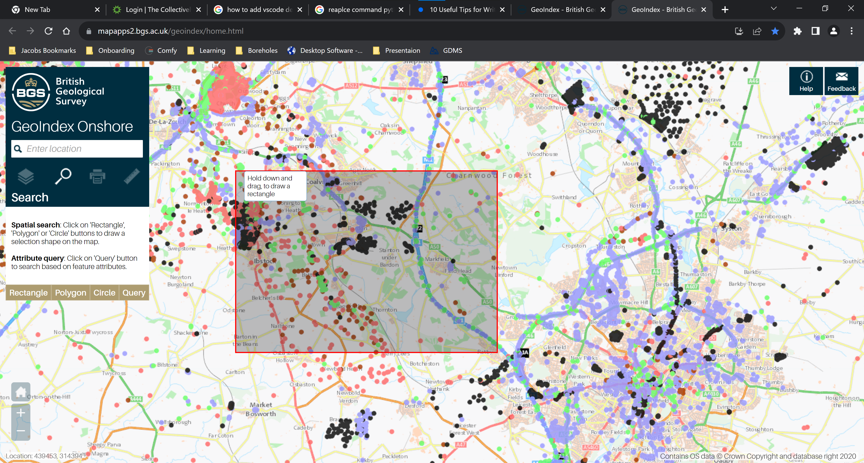

* Export the selection you desire, and ensure the file name is GeoIndexData.txt, the program will not work if it is in any other form (such as GeoIndexData(2).txt)

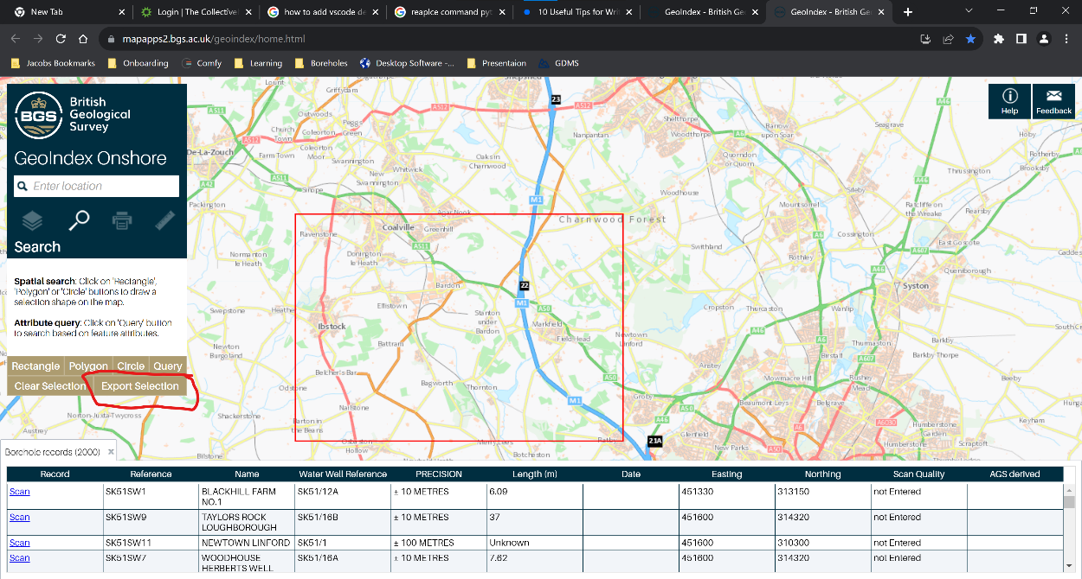

### Running download program

* Create a folder where you want to run the file, and add in the executable file and the GeoIndexData.txt file. Ensure the folder name does not contain special characters or spaces. For example a bad title: M1 J20-30, a better example: M1_J20-30.

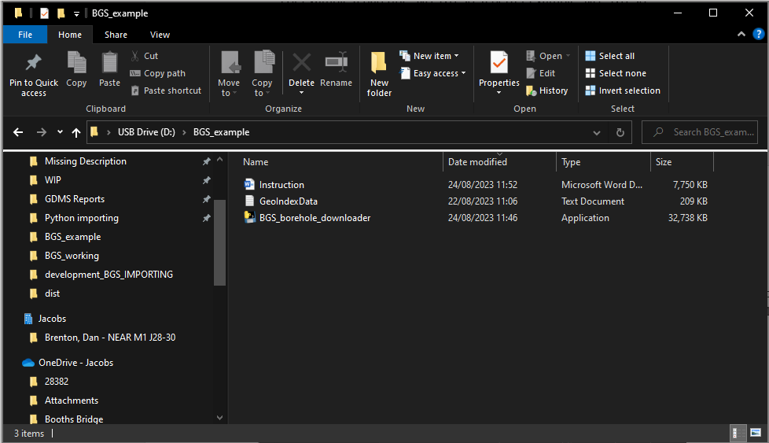

* Double click on the file and run it, and once it has been completed your folder should look like the image below. (note the program can take ~30 min when downloading near its 1000 file limit, you can check task monitor for python to see when the program finishes)

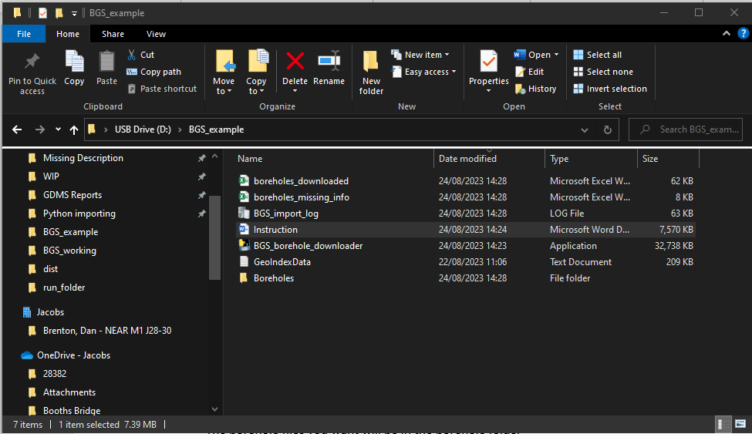

* The excel file **boreholes_downloaded.xlsx** will show info for the downloaded boreholes, the file **boreholes_missing_info.xlsx** contains the boreholes that were not downloaded as their record is missing (likely confidential), and if **boreholes_not_downloaded.xlsx** appears then there has been an error for one or more boreholes, and so these ones will need to be downloaded manually (this file will not show if there has not been any errors as it only shows if the program finds a problem record)
* The borehole files you want will be in the borehole folder, **make sure you check you have all the boreholes you want.**

### Run again

* If you want to run the program again for another set of boreholes, just replace the GeoIndexData.txt file and run again